After training the data and finding the right model to best determine a better ticket price for Big Mountain resort, we saw that from its original price of $81, we can raise the price up to $95.87, with an expected mean, (give or take) an extra of $10.37 dollars, which suggest that there is room for increase in ticket price. From our data we deduce that the more prominent features of resorts are the following: vertical drop, snow made, total chairs, fast quads, number of runs, longest run, trams, and skiable terrain. Big Mountain in comparison to other ski resorts have more of the prominent features to utilize. Below are some graphs comparing Big Mountain to the others.

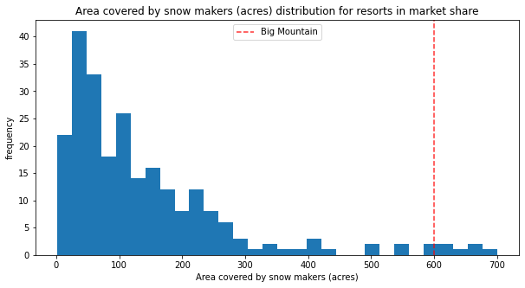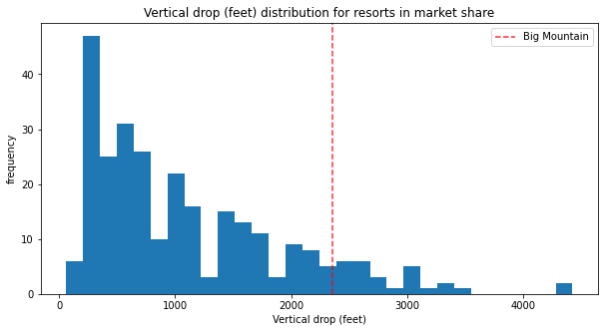

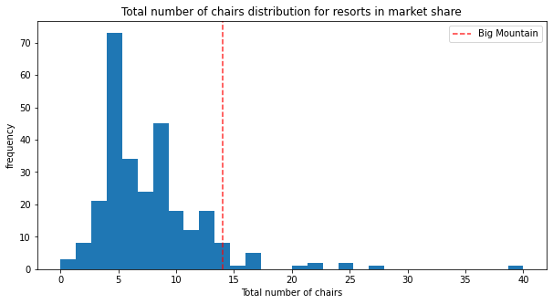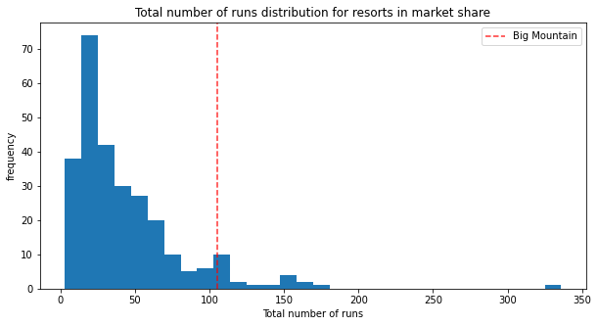

From the 4 business scenarios that Big Mountain Resort is considering, the first one says that closing down 2 and 3 runs will successfully reduce the support for ticket price by 75c, however if Big Mountain decides to close down 3 runs, it could also close down up to 2 more (for a total of 5) without any further loss in ticket price. Closing 6 would lead to loss in revenue. 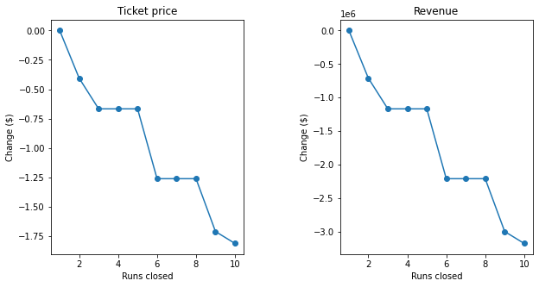

Scenario 2, where Big Mountain plans on adding a run, increasing the vertical drop by 150 feet with he installation of an additional chair lift could support a ticket price increase of $8.61. Over the season this could lead to $15,065,471.

Scenario 3 is to add 2 acres of snow making and could support an increase for ticket price by $9.90. Which overall throughout the season is an expected amount of $17,322,717.

However scenario 4, increasing the longest run by .2 miles does not make a difference whatsoever.